|  |  |  |
| --- | --- | --- |
| SharePoint 2010 Move Sites Powershell Script Usage Guide V1.0 | 2011 | |
| This document contains all instructions and usage outlines for the SharePoint 2010 PowerShell Move Sites Script | |  |



Contents

SharePoint 2010 Move Site PowerShell Script 2

Disclaimer 2

Intended Usage 2

How the Script works – What it actually does… 2

GeneralNotes 3

Perquisitesbeforerunningthescript 3

Running the script 4

Annex 1 – The Script (V1.0) 7

# SharePoint 2010 Move Site PowerShell Script

# Disclaimer

This tool is provided as is and is used and implemented at the users own risk. You may use this tool for any purpose as long as any communication/feedback accredits Heath Groves of [www.SundownSolutions.co.uk](http://www.SundownSolutions.co.uk) with the original source code.

# Intended Usage

This tool is designed to be used for:

* **Moving Sites between Test and Live environments**
* **Moving sites between site collections**
* **Moving sites within Site Collections**
* **Moving Sites between Web applications**
* **Change the URL of a site location by moving it**

# How the Script works – What it actually does…

The script starts by creating a directory on the C: drive called c:\SundownSolutions. It then takes the URL supplied for export (<http://webapp/SitetoExport>/) and runs the **Export-SPWeb** command and saves the subsequent file to c:\SundownSolutions\SiteName+Date.cmp (It may take some time for the file to export depending on the size of the site)

At this point you have to manually select the base template that was used to create the site for export – the script will open a browser page displaying a list of all the template codes and names for your reference.

*\*\*\* There is a technical reason why the script can’t retrieve the template programmatically. For the full detailed explanation please see this blog post:*

[*http://www.sp2010blog.com/Blog/Lists/Posts/Post.aspx?ID=49*](http://www.sp2010blog.com/Blog/Lists/Posts/Post.aspx?ID=49)

The script creates a new site using the site URL based on the details provided in the dialog box. It then imports the exported site from c:\SundownSolutions\SiteName+Date.cmp which goes over the newly created site settings.

The script then deletes the .cmp file but leaves the SundownSolutions folder in place so that you can review the log files

# GeneralNotes

The export and import takes care of service activation

The way the script works (By creating a new site and then importing a cmp definition over the top) means that it will work with ALL default templates – Including publishing! ☺

This script is version one and as such it is to modified and updated accordingly with increasing functionality – feel free to add and rationalise the code as necessary.

Export only keeps the last major version of a file (i.e. it gets rid of the previous versions)

# Perquisitesbeforerunningthescript

You must be an administrator to the run the script and your PowerShell environment must be configured to allow remote scripts to run – this can be achieved by running the command:

set-executionpolicy remotesigned

*see this link for details:

<http://technet.microsoft.com/en-us/library/dd347628.aspx>

Please ensure that you run the script from the main Indexer/Central administration server – The script can in fact be ran from any SharePoint server, but using the indexer will help reduce any potential issues if troubleshooting is needed.

# Running the script

There are two ways to run the script, directly from the command shell, or using the Integrated Scripting Environment (ISE). This guide will show you how to use the shell version but using the ISE is recommended if you require trouble shooting information.

1. Copy the script to your **Index/Central admin** server – the desktop if fine. Right click the script and select **Run with PowerShell**

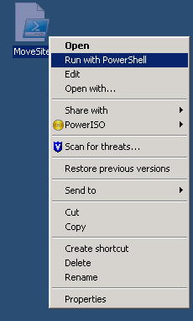

1. You will be presented with the first dialog box – enter the path to the site you wish to export or move using only the name of the site (no page references) and you must include the / at the end – *example: if I wanted to export a sub site called* ***test*** *under a web app called* ***SundownSolutions.co.uk*** *then the path to be entered would be* [***http://SundownSolutions.co.uk/test/***](http://SundownSolutions.co.uk/test/)

Press **Next** to start the export

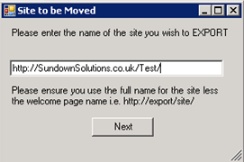

1. The next Screen is the template selection screen. You will need to select the template that was originally used to create the site you wish to export. In my scenario I have to find out what template was originally used to create the [**http://SundownSolutions.co.uk/test/**](http://SundownSolutions.co.uk/test/)website. At present this cannot be automated due to the reasons listed here:

<http://www.sp2010blog.com/Blog/Lists/Posts/Post.aspx?ID=49>

An IE browser will also open with a link to the current list of default templates to help you find the right template name and code:

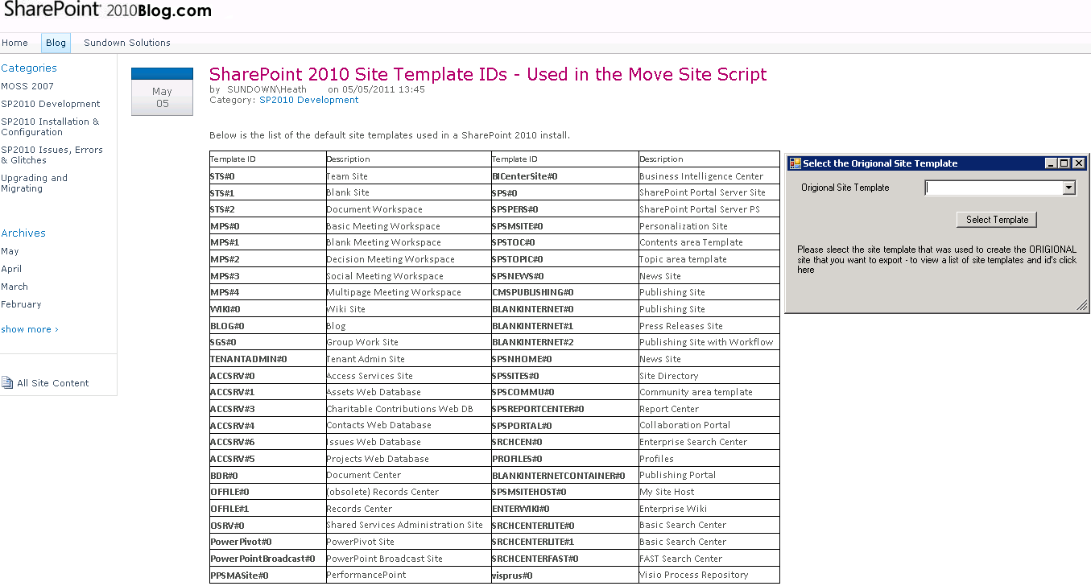

Select the correct code from the drop down list and press the select template button

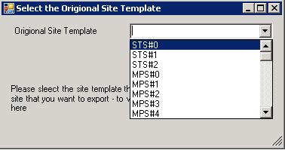

*\*\*\*\*If you proceed with the script and you have selected the wrong the site code (for instance the site to be exported was made using a publishing site – but you selected team site instead) the script will exit (eventually, once it’s gone through all the parameters of course!) and tell you which template should be use, make a note of it! – if you rerun the script using this recommended template designation it will subsequently work.*

1. Once the export is complete (it may take some time!) you will be shown the import dialog box. Enter the TOP LEVEL Site name that you want the exported site to sit UNDER. Then enter your new site URL and press **Start Import**.

The Site title will remain the same as the exported version.

*\*\* In this instance I want to move my test site in the same web app, but under a different URL so I type in the same top level site* [*http://sundownsolutions.co.uk/*](http://sundownsolutions.co.uk/) *but give it the new URL name of NewSiteLocation – this means the site will deploy to* [*http://sundownsolutions.co.uk/NewSiteLocation*](http://sundownsolutions.co.uk/NewSiteLocation)

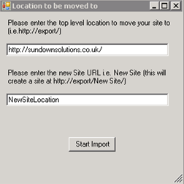

***Note:*** *The URL can contain spaces; I have just left them out here for ease of use*

1. After a short period of time (Depending on the size of the site you will be shown the Congratulations dialogue box:

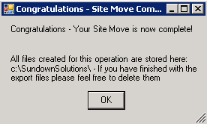

Your site move should now be complete.

You will be able to review all the log files in the **C:\SundownSolutions\** folder on the server.

# Annex 1 – The Script (V1.0)

The following is the base code contained within the script:

#----------------------------------------------------------------------------------------------------Adds SharePoint Module

Add-PsSnapin Microsoft.SharePoint.PowerShell

#----------------------------------------------------------------------------------------------------Dialog Box 1 - Site to be exported

[void] [System.Reflection.Assembly]::LoadWithPartialName("System.Drawing")

[void] [System.Reflection.Assembly]::LoadWithPartialName("System.Windows.Forms")

$objForm = New-Object System.Windows.Forms.Form

$objForm.Text = "Site to be Moved"

$objForm.Size = New-Object System.Drawing.Size(300,200)

$objForm.StartPosition = "CenterScreen"

$objForm.KeyPreview = $True

$objForm.Add_KeyDown({if ($_.KeyCode -eq "Enter")

{$x=$objTextBox.Text;$objForm.Close()}})

$objForm.Add_KeyDown({if ($_.KeyCode -eq "Escape")

{$objForm.Close()}})

$OKButton = New-Object System.Windows.Forms.Button

$OKButton.Location = New-Object System.Drawing.Size(110,120)

$OKButton.Size = New-Object System.Drawing.Size(75,23)

$OKButton.Text = "Next"

$OKButton.Add_Click({$SiteToExport=$objTextBox.Text;$objForm.Close()})

$objForm.Controls.Add($OKButton)

$objLabel = New-Object System.Windows.Forms.Label

$objLabel.Location = New-Object System.Drawing.Size(10,10)

$objLabel.Size = New-Object System.Drawing.Size(280,40)

$objLabel.Text = "Please enter the name of the site you wish to EXPORT"

$objForm.Controls.Add($objLabel)

$objLabel1 = New-Object System.Windows.Forms.Label

$objLabel1.Location = New-Object System.Drawing.Size(10,80)

$objLabel1.Size = New-Object System.Drawing.Size(280,40)

$objLabel1.Text = "Please ensure you use the full name for the site less the welcome page name i.e. http://export/site/"

$objForm.Controls.Add($objLabel1)

$objTextBox = New-Object System.Windows.Forms.TextBox

$objTextBox.Location = New-Object System.Drawing.Size(10,50)

$objTextBox.Size = New-Object System.Drawing.Size(260,20)

$objForm.Controls.Add($objTextBox)

$objForm.Topmost = $True

$objForm.Add_Shown({$objForm.Activate()})

[void] $objForm.ShowDialog()

#----------------------------------------------------------------------------------------------------Opens the Browser link to SP2010 blog that lists the Site Templates and Codes

$ie = new-object -comobject "InternetExplorer.Application"

$ie.visible = $true

$ie.navigate("http://www.sp2010blog.com/Blog/Lists/Posts/Post.aspx?ID=48")

#----------------------------------------------------------------------------------------------------User selects origional site template

[array]$DropDownArray = "STS#0","STS#1","STS#2","MPS#0","MPS#1","MPS#2","MPS#3","MPS#4","WIKI#0","BLOG#0","SGS#0","TENANTADMIN#0","ACCSRV#0","ACCSRV#1","ACCSRV#3","ACCSRV#4","ACCSRV#6","ACCSRV#5","BDR#0","OFFILE#0","OFFILE#1","OSRV#0","PowerPivot#0","PowerPointBroadcast#0","PPSMASite#0","BICenterSite#0","SPS#0","SPSPERS#0","SPSMSITE#0","SPSTOC#0","SPSTOPIC#0","SPSNEWS#0","CMSPUBLISHING#0","BLANKINTERNET#0","BLANKINTERNET#1","BLANKINTERNET#2","SPSNHOME#0","SPSSITES#0","SPSCOMMU#0","SPSREPORTCENTER#0","SPSPORTAL#0","SRCHCEN#0","PROFILES#0","BLANKINTERNETCONTAINER#0","SPSMSITEHOST#0","ENTERWIKI#0","SRCHCENTERLITE#0","SRCHCENTERLITE#1","SRCHCENTERFAST#0","visprus#0"

# This Function Returns the Selected Value and Closes the Form

function Return-DropDown {

$Choice = $DropDown.SelectedItem.ToString()

$Form.Close()

Write-Host $Choice

}

[System.Reflection.Assembly]::LoadWithPartialName("System.Windows.Forms")

[System.Reflection.Assembly]::LoadWithPartialName("System.Drawing")

$Form = New-Object System.Windows.Forms.Form

$Form.width = 380

$Form.height = 200

$Form.Text = ”Select the Origional Site Template”

$Form.StartPosition = "CenterScreen"

$DropDown = new-object System.Windows.Forms.ComboBox

$DropDown.Location = new-object System.Drawing.Size(170,10)

$DropDown.Size = new-object System.Drawing.Size(190,30)

ForEach ($Item in $DropDownArray) {

$DropDown.Items.Add($Item)

}

$Form.Controls.Add($DropDown)

$DropDownLabel = new-object System.Windows.Forms.Label

$DropDownLabel.Location = new-object System.Drawing.Size(15,13)

$DropDownLabel.size = new-object System.Drawing.Size(150,20)

$DropDownLabel.Text = "Origional Site Template"

$Form.Controls.Add($DropDownLabel)

$Button = new-object System.Windows.Forms.Button

$Button.Location = new-object System.Drawing.Size(210,50)

$Button.Size = new-object System.Drawing.Size(100,20)

$Button.Text = "Select Template"

$Button.Add_Click({Return-DropDown})

$form.Controls.Add($Button)

$DropDownExplination = new-object System.Windows.Forms.Label

$DropDownExplination.Location = new-object System.Drawing.Size(10,90)

$DropDownExplination.size = new-object System.Drawing.Size(380,60)

$DropDownExplination.Text = "Please sleect the site template that was used to create the ORIGIONAL site that you want to export - to view a list of site templates and id's click here"

$Form.Controls.Add($DropDownExplination)

$Form.Add_Shown({$Form.Activate()})

$Form.ShowDialog()

[string] $DropDown = [System.Convert]::ToString($TemplateName)

#----------------------------------------------------------------------------------------------------Creates the storage Folder

[IO.Directory]::CreateDirectory("c:\SundownSolutions")

#----------------------------------------------------------------------------------------------------Exports the Web Site to its own date and time stamped file

$Date = Get-Date

$Filename="ExportedSite{0:d2}{1:d2}{2:d2}-{3:d2}{4:d2}.cmp" -f $date.day,$date.month,$date.year,$date.hour,$date.minute

$Filename2 = "c:\SundownSolutions\" + $Filename

Export-SPWeb $SiteToExport –Path $FileName2

#----------------------------------------------------------------------------------------------------Dialog Box 2 - Import Location

[void] [System.Reflection.Assembly]::LoadWithPartialName("System.Drawing")

[void] [System.Reflection.Assembly]::LoadWithPartialName("System.Windows.Forms")

$objForm = New-Object System.Windows.Forms.Form

$objForm.Text = "Location to be moved to"

$objForm.Size = New-Object System.Drawing.Size(300,300)

$objForm.StartPosition = "CenterScreen"

$objForm.KeyPreview = $True

$objForm.Add_KeyDown({if ($_.KeyCode -eq "Enter")

{$x=$objTextBox.Text;$objForm.Close()}})

$objForm.Add_KeyDown({if ($_.KeyCode -eq "Escape")

{$objForm.Close()}})

$OKButton = New-Object System.Windows.Forms.Button

$OKButton.Location = New-Object System.Drawing.Size(110,200)

$OKButton.Size = New-Object System.Drawing.Size(75,23)

$OKButton.Text = "Start Import"

$OKButton.Add_Click({$ImportLocation=$objTextBox.Text;$objForm.Close()})

$OKButton.Add_Click({$SiteTitle=$objTextBoxTitle.Text;$objForm.Close()})

$objForm.Controls.Add($OKButton)

$objLabel = New-Object System.Windows.Forms.Label

$objLabel.Location = New-Object System.Drawing.Size(10,10)

$objLabel.Size = New-Object System.Drawing.Size(280,40)

$objLabel.Text = "Please enter the top level location to move your site to (i.e.http://export/)"

$objForm.Controls.Add($objLabel)

$objTextBox = New-Object System.Windows.Forms.TextBox

$objTextBox.Location = New-Object System.Drawing.Size(10,50)

$objTextBox.Size = New-Object System.Drawing.Size(260,20)

$objForm.Controls.Add($objTextBox)

$objLabelTitle = New-Object System.Windows.Forms.Label

$objLabelTitle.Location = New-Object System.Drawing.Size(10,90)

$objLabelTitle.Size = New-Object System.Drawing.Size(280,40)

$objLabelTitle.Text = "Please enter the new Site URL i.e. New Site (this will create a site at http://export/New Site/)"

$objForm.Controls.Add($objLabelTitle)

$objTextBoxTitle = New-Object System.Windows.Forms.TextBox

$objTextBoxTitle.Location = New-Object System.Drawing.Size(10,130)

$objTextBoxTitle.Size = New-Object System.Drawing.Size(260,20)

$objForm.Controls.Add($objTextBoxTitle)

$objForm.Topmost = $True

$objForm.Add_Shown({$objForm.Activate()})

[void] $objForm.ShowDialog()

#----------------------------------------------------------------------------------------------------Create new site based on Template and name chosen

New-SPWeb $importLocation$SiteTitle -Template $TemplateName -Name $SiteTitle

#----------------------------------------------------------------------------------------------------Imports the web site

Import-SPWeb $ImportLocation$SiteTitle –Path $FileName2 –UpdateVersions Overwrite

#----------------------------------------------------------------------------------------------------End Of Operation Menu

[void] [System.Reflection.Assembly]::LoadWithPartialName("System.Drawing")

[void] [System.Reflection.Assembly]::LoadWithPartialName("System.Windows.Forms")

$objForm = New-Object System.Windows.Forms.Form

$objForm.Text = "Congratulations - Site Move Complete"

$objForm.Size = New-Object System.Drawing.Size(280,170)

$objForm.StartPosition = "CenterScreen"

$objForm.KeyPreview = $True

$objForm.Add_KeyDown({if ($_.KeyCode -eq "Enter")

{$x=$objTextBox.Text;$objForm.Close()}})

$objForm.Add_KeyDown({if ($_.KeyCode -eq "Escape")

{$objForm.Close()}})

$objLabelTitle = New-Object System.Windows.Forms.Label

$objLabelTitle.Location = New-Object System.Drawing.Size(10,10)

$objLabelTitle.Size = New-Object System.Drawing.Size(280,40)

$objLabelTitle.Text = "Congratulations - Your Site Move is now complete!"

$objForm.Controls.Add($objLabelTitle)

$objLabelTitle = New-Object System.Windows.Forms.Label

$objLabelTitle.Location = New-Object System.Drawing.Size(10,50)

$objLabelTitle.Size = New-Object System.Drawing.Size(280,40)

$objLabelTitle.Text = "All files created for this operation are stored here: c:\SundownSolutions\ - If you have finished with the export files please feel free to delete them"

$objForm.Controls.Add($objLabelTitle)

$OKButton = New-Object System.Windows.Forms.Button

$OKButton.Location = New-Object System.Drawing.Size(115,100)

$OKButton.Size = New-Object System.Drawing.Size(50,25)

$OKButton.Text = "OK"

$OKButton.Add_Click({$End=$objTextBox.Text;$objForm.Close()})

$OKButton.Add_Click({$Endok=$objTextBoxTitle.Text;$objForm.Close()})

$objForm.Controls.Add($OKButton)

[void] $objForm.ShowDialog()

#----------------------------------------------------------------------------------------------------Deletes all files from the folder excvept the log files (to ensure large .cmp files arn't left on the C: Drive!)

Remove-Item c:\sundownsolutions\* -exclude *.txt,*.log

#----------------------------------------------------------------------------------------------------Dispose all objects in the script - cleaning up :)

function Dispose-All {

Get-Variable -exclude Runspace |

Where-Object {

$_.Value -is [System.IDisposable]

} |

Foreach-Object {

$_.Value.Dispose()

Remove-Variable $_.Name

}

}

#----------------------------------------------------------------------------------------------------Notes Section

#Variables that are used in this script

#$SiteToExport

#$Template

#$web.WebTemplate

#$ImportLocation

#$SiteTitle

#$DropDown - Used to select the template (before converted to string)

#$TemplateName - After string copnversion

#Date

#Filename

#Filename2